TCC Cloud Computing

E-Commerce Inventory Management System on AWS Academy Learner

Lab

Group Name: Apex

Members:

|  |  |  |
| --- | --- | --- |
| Name | ID | Major |
| Cheong Ji Xiang | 1201300548 | ST |
| Darren Soo Chen Yee | 1181200950 | DCN |
| Loh Chun Yuen | 1181203400 | DCN |
| Nicholas Lee Ze Xuan | 1181102808 | ST |

Public IPv4: 184.72.103.97

**Phase 1 – Build a Simple System**

create ec2

Settings need change for ec2:

* instance type: t2.medium
* key pair: create new key pair( [any name], rsa, pem) > create key
* network settings: allow https and http traffic from the internet
* Other settings remain default.

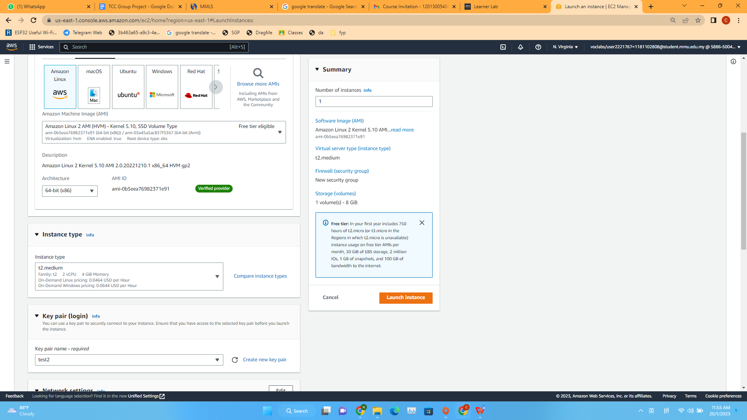

create s3

settings:

* object ownership: ACLs enable
* uncheck block all public access
* create

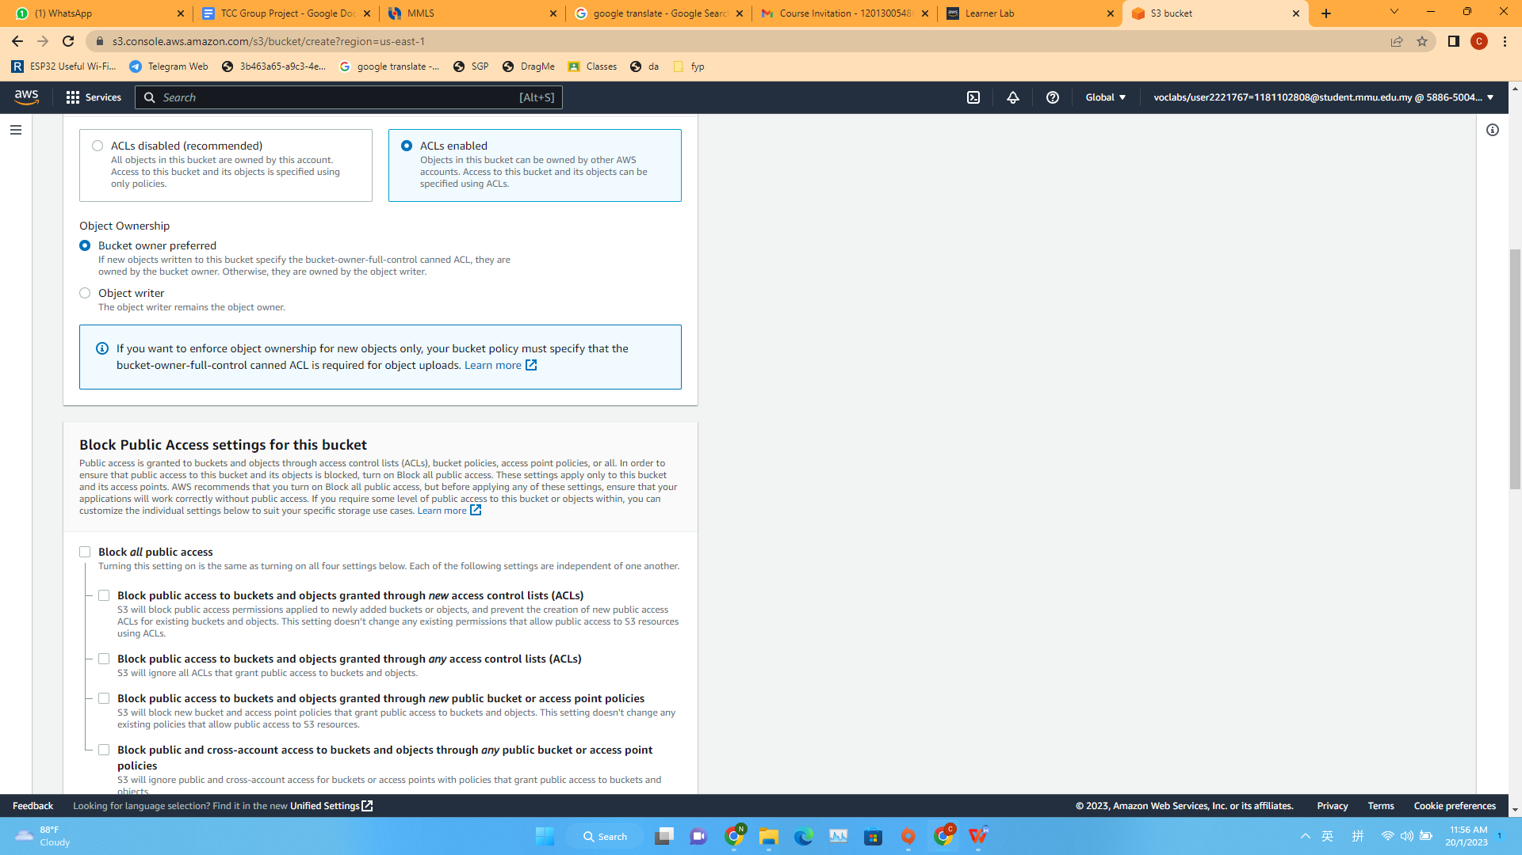

upload website coding zip to s3,

check all file, action > make public using acls

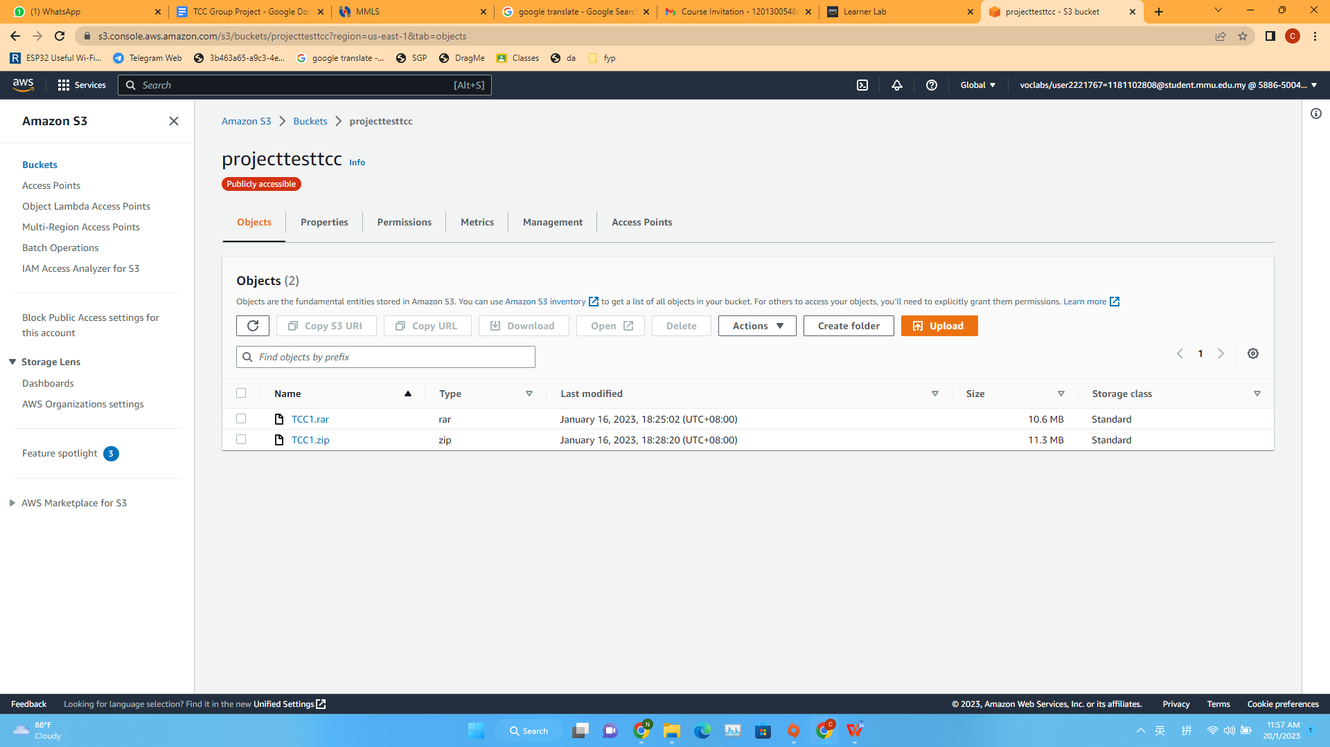

Copy public ipv4 paste in putty then run

Login as : ec2-user

Code: yum install -y httpd php mysql-server    (download server, php and mysql)

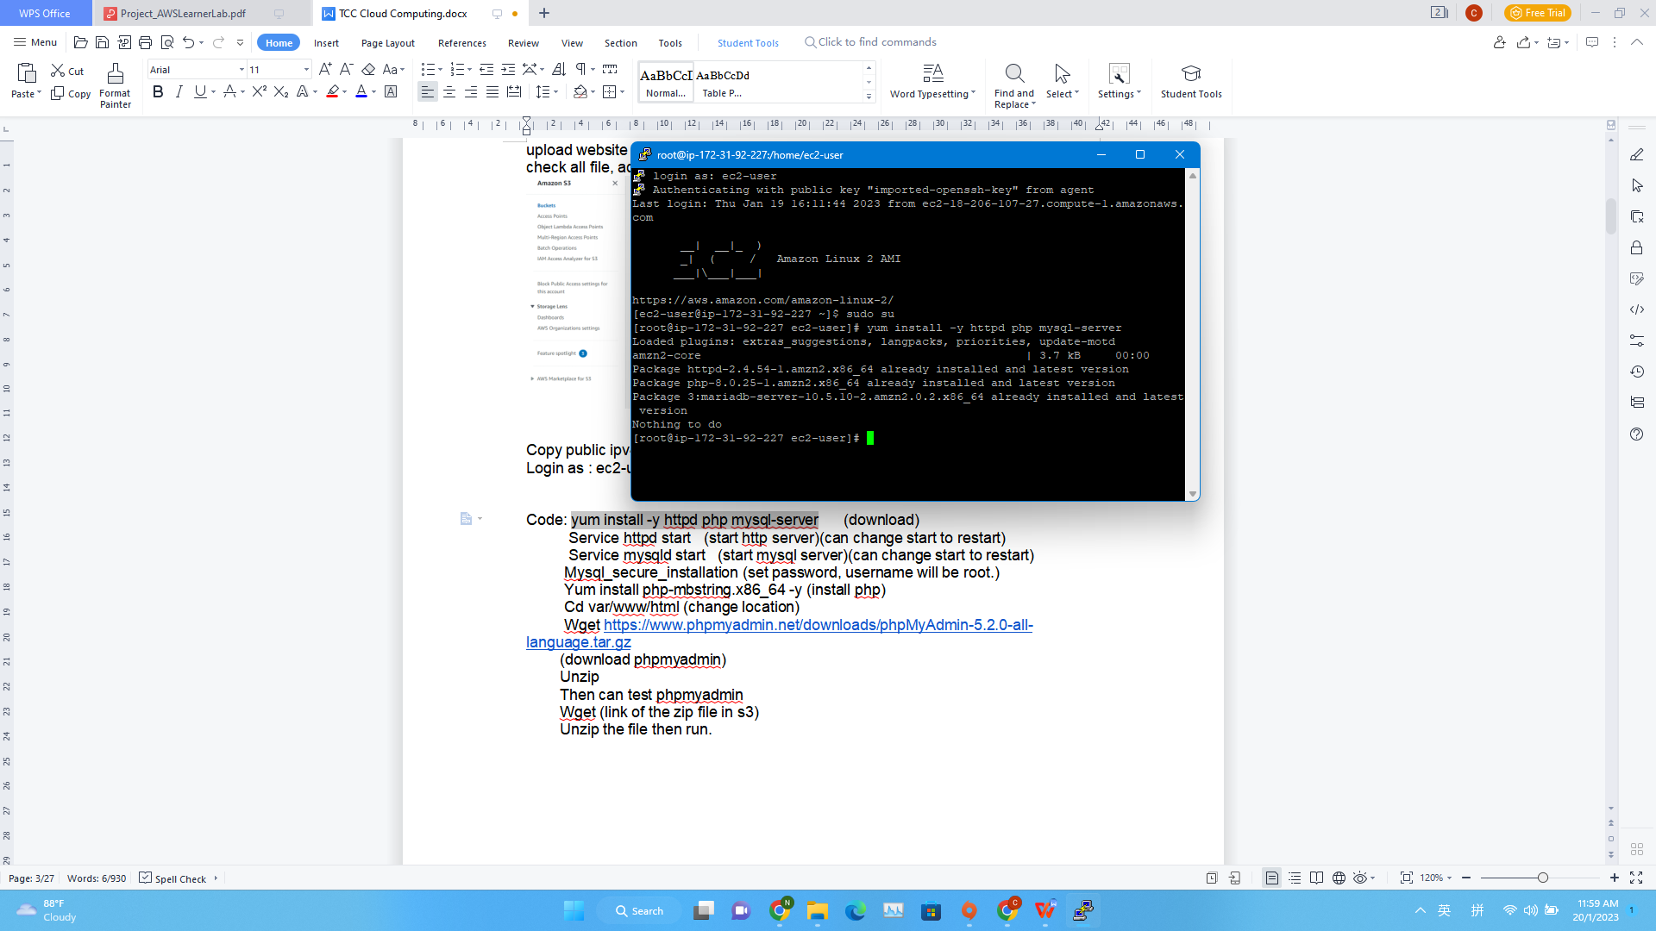

 Code:Service httpd start (start http server)(can change start to restart)

          Service mysqld start(start mysql server)(can change start to restart)

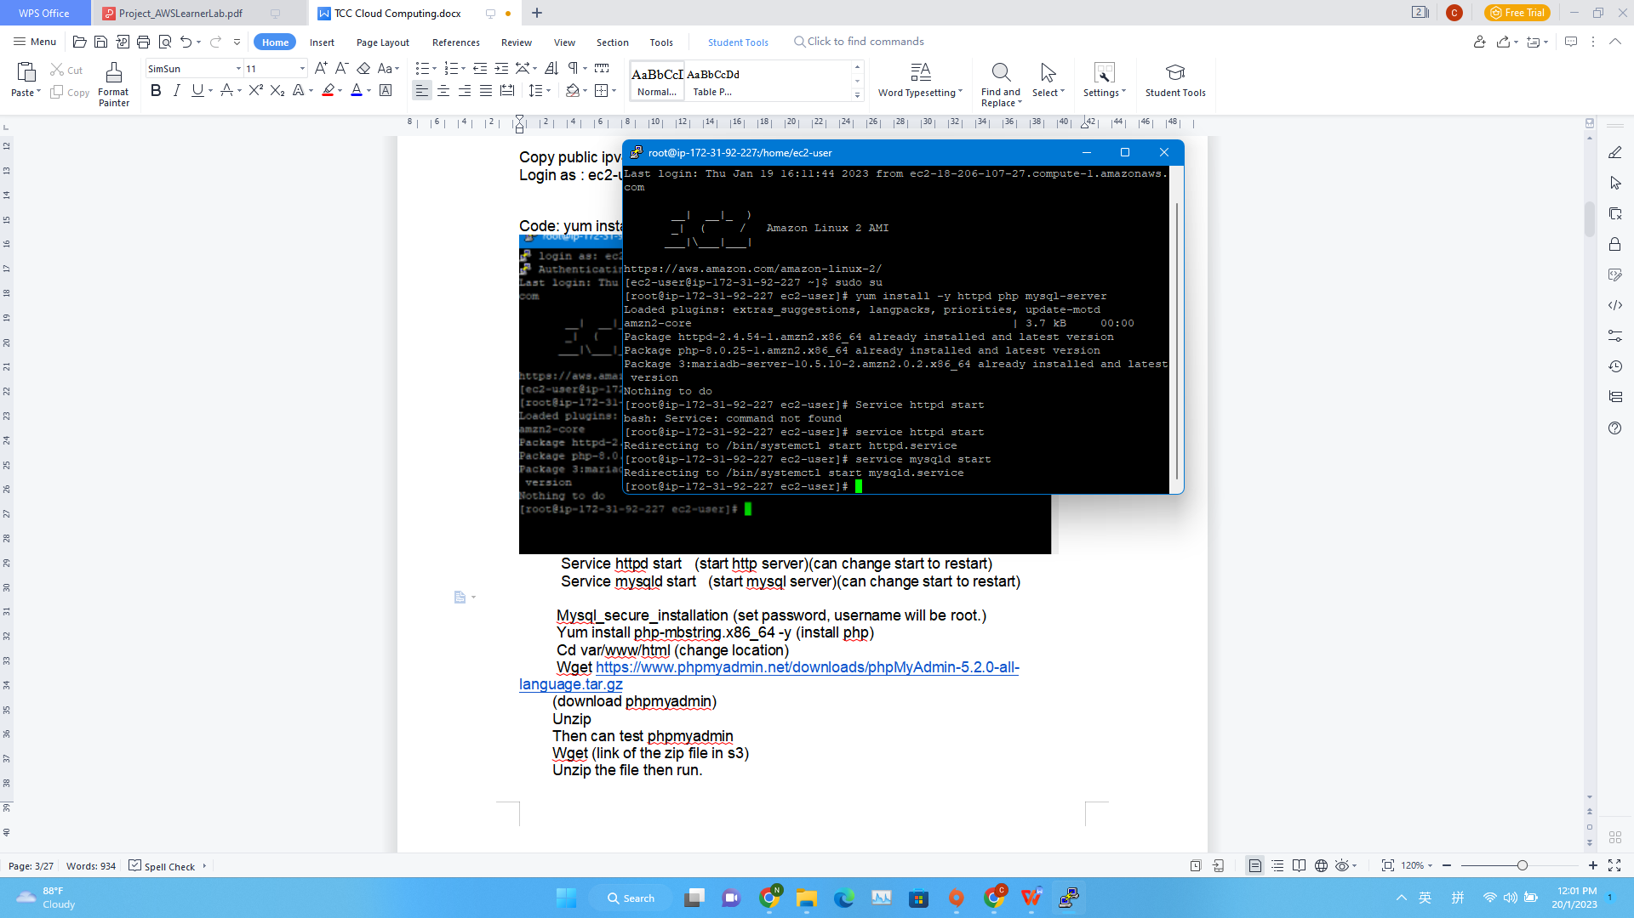

Code: Mysql_secure_installation (set password, username will be root.)

         Yum install php-mbstring.x86_64 -y (install php)

         Cd var/www/html (change location)

         Wget <https://www.phpmyadmin.net/downloads/phpMyAdmin-5.2.0-all-language.tar.gz>               (download myphpadmin)

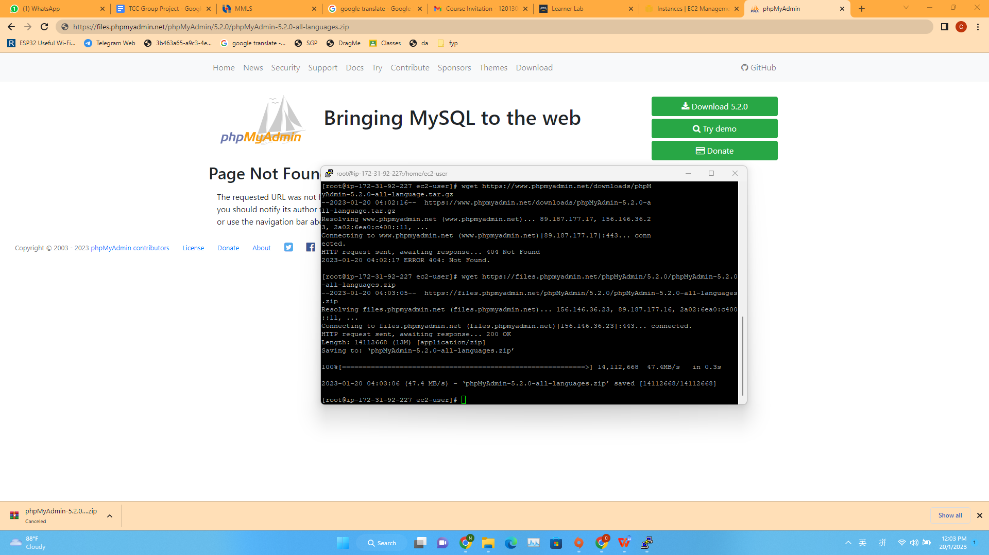

        Unzip, then can test phpmyadmin

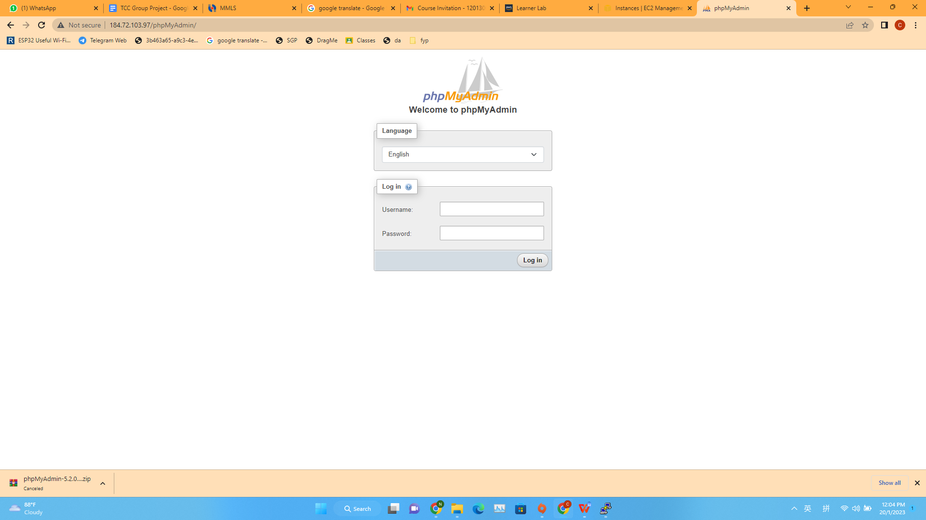

        Wget (link of the website coding zip file in s3)

        Unzip the file then run.

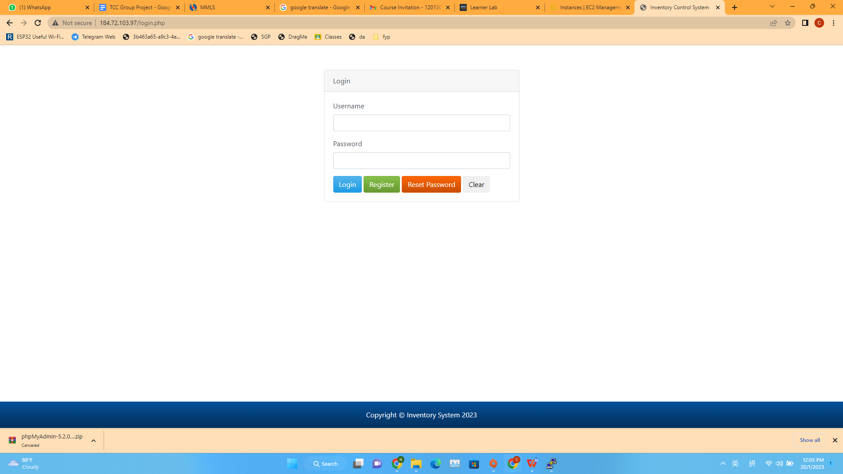

Register function

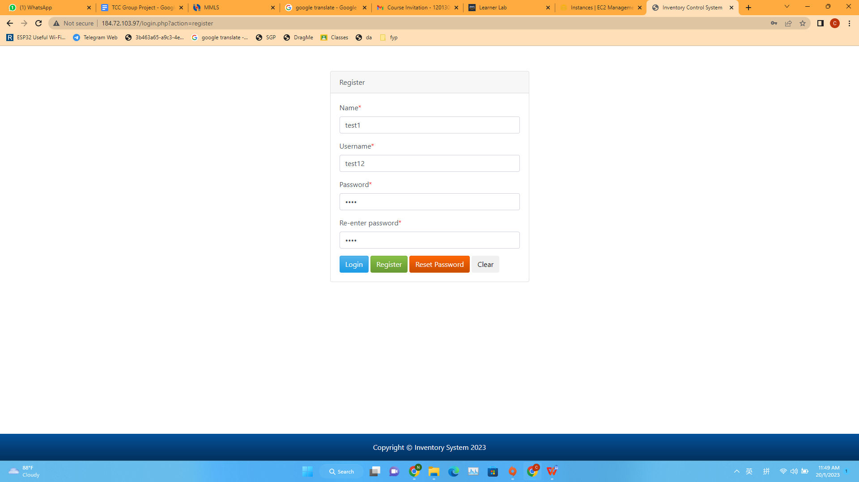

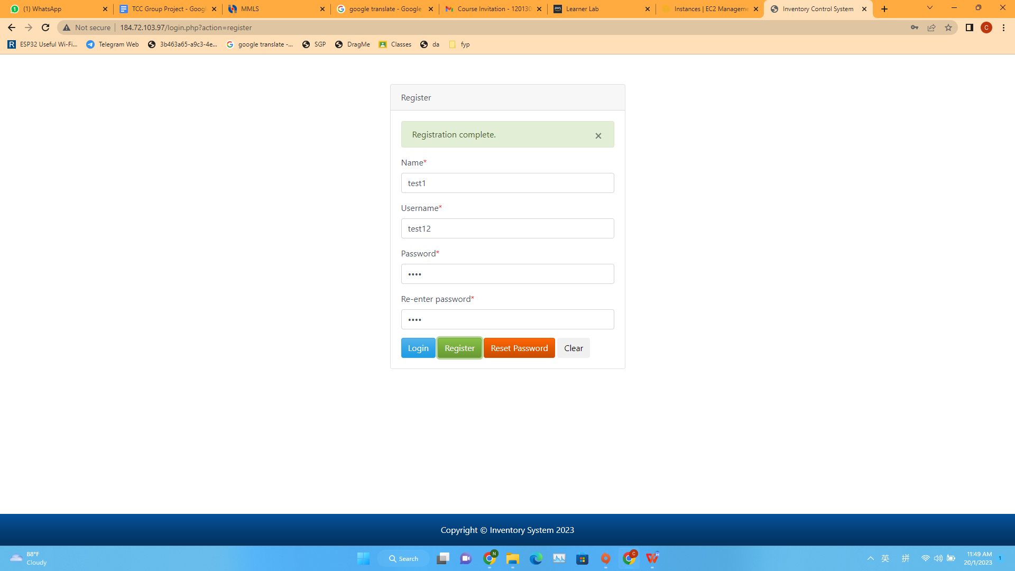

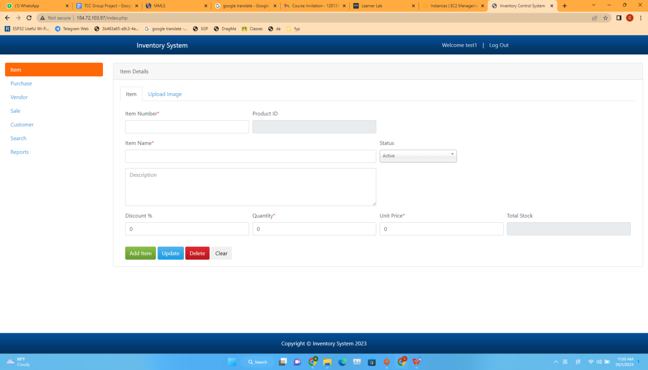

Default Database data

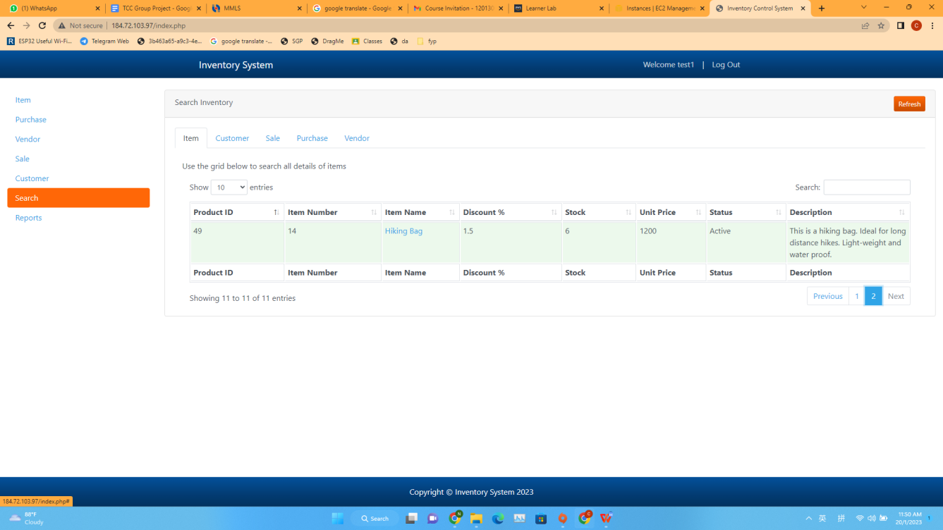

Add a new test item into the database

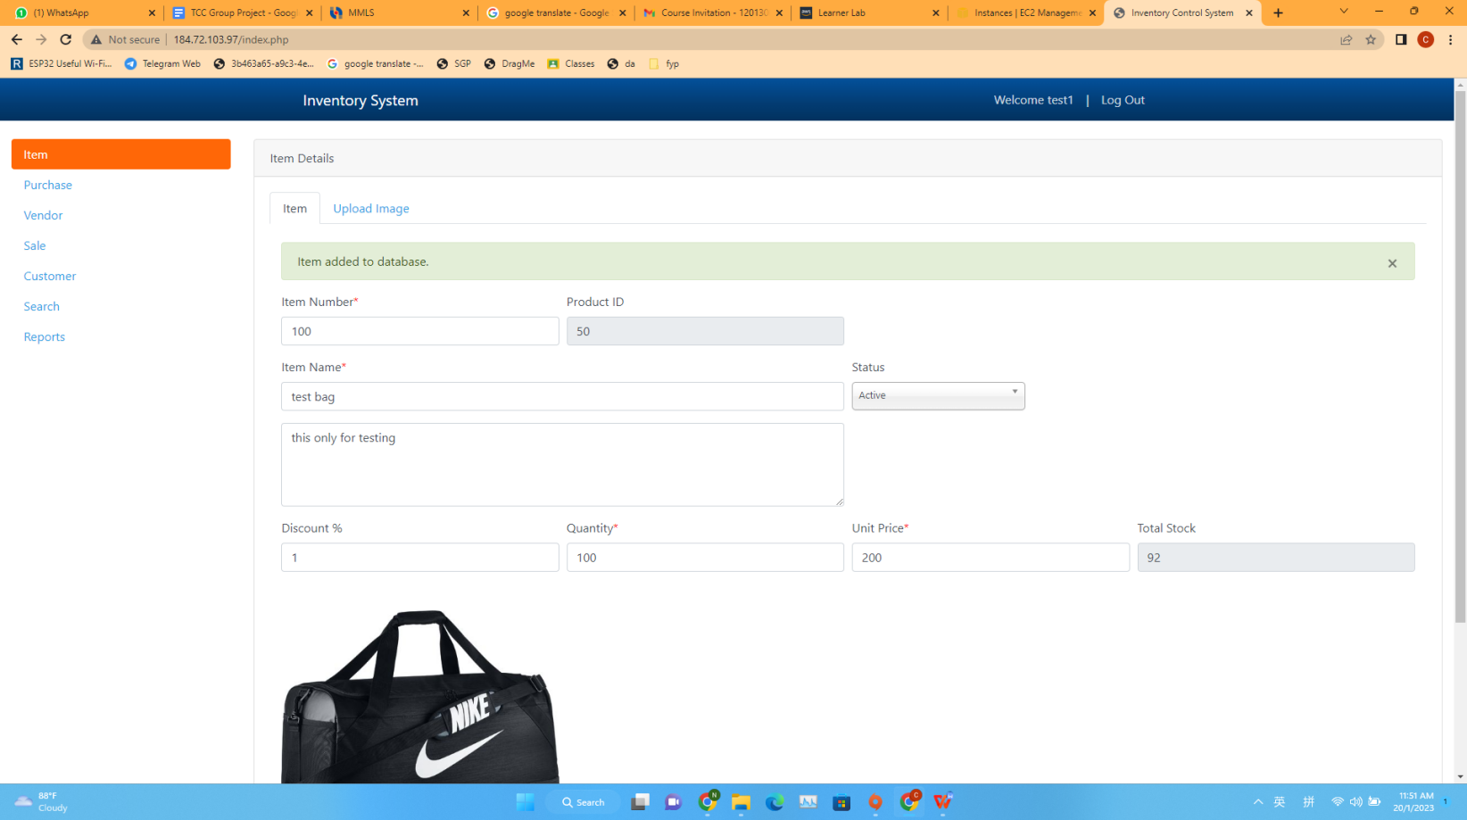

Updated database

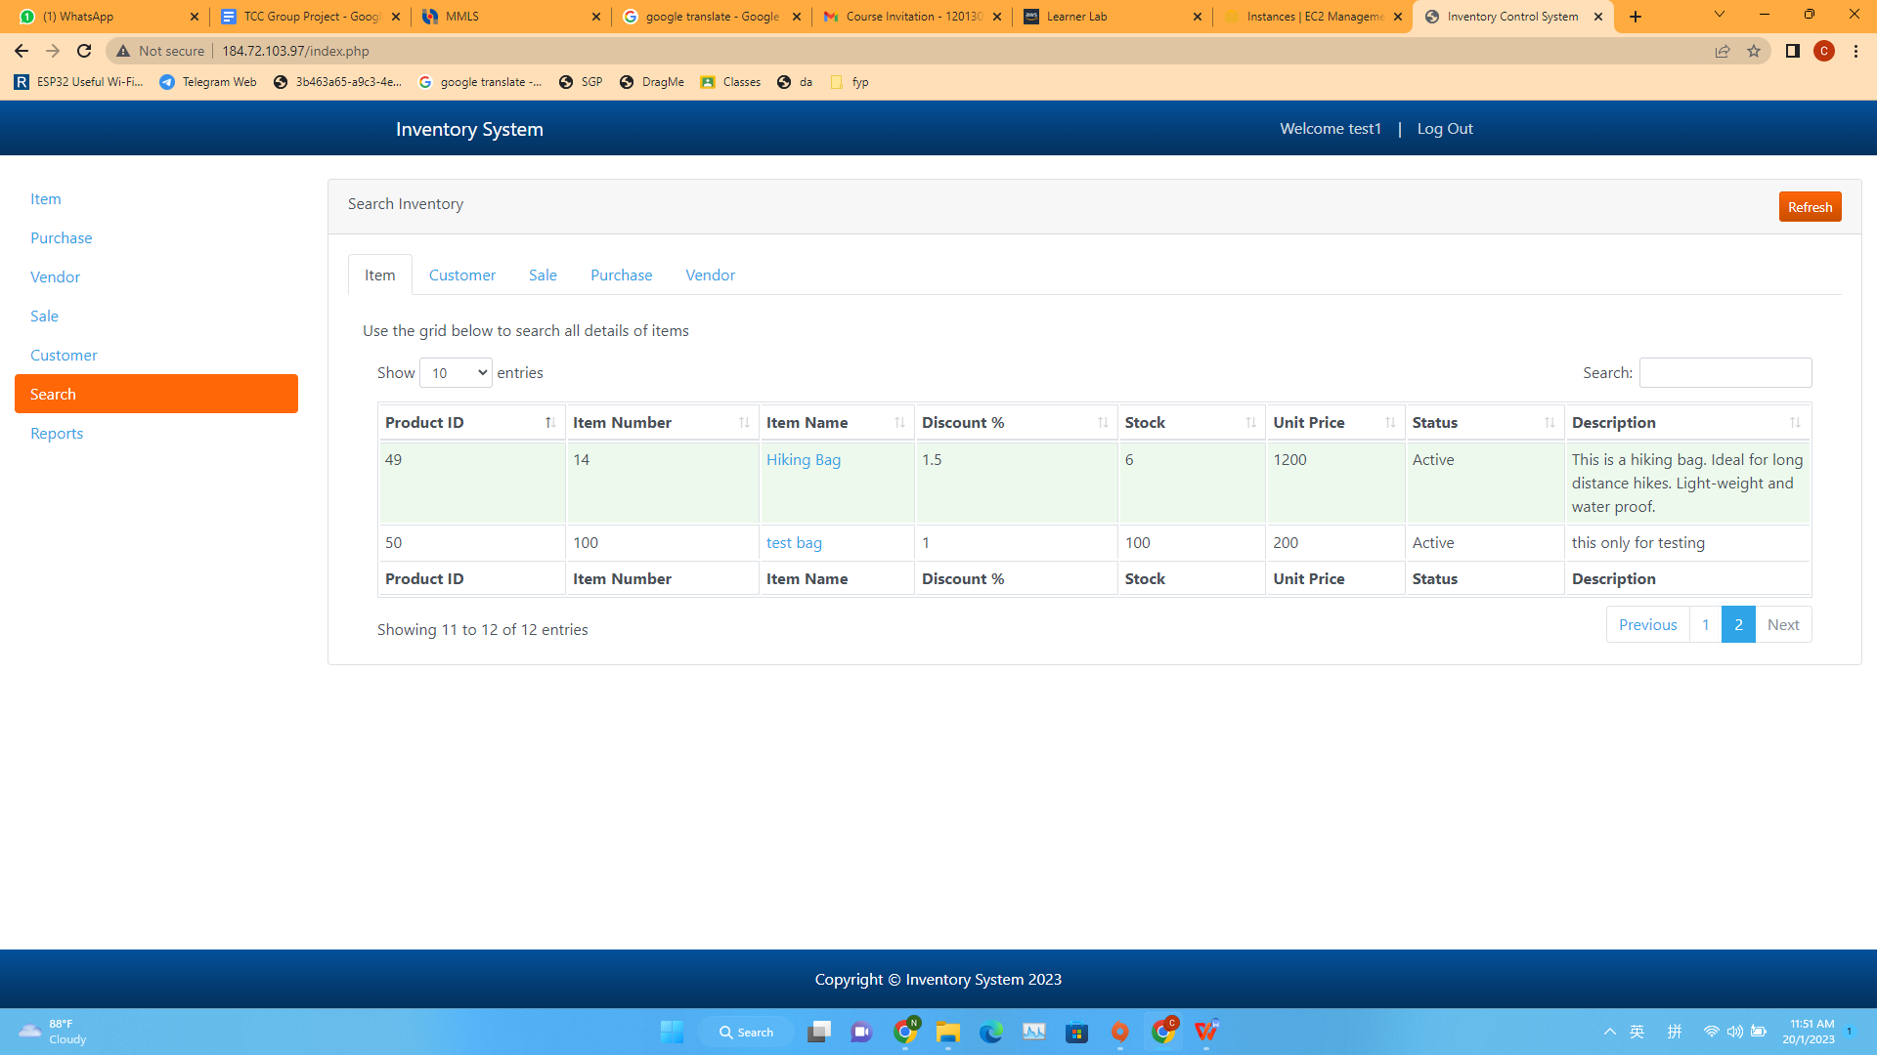

Delete item

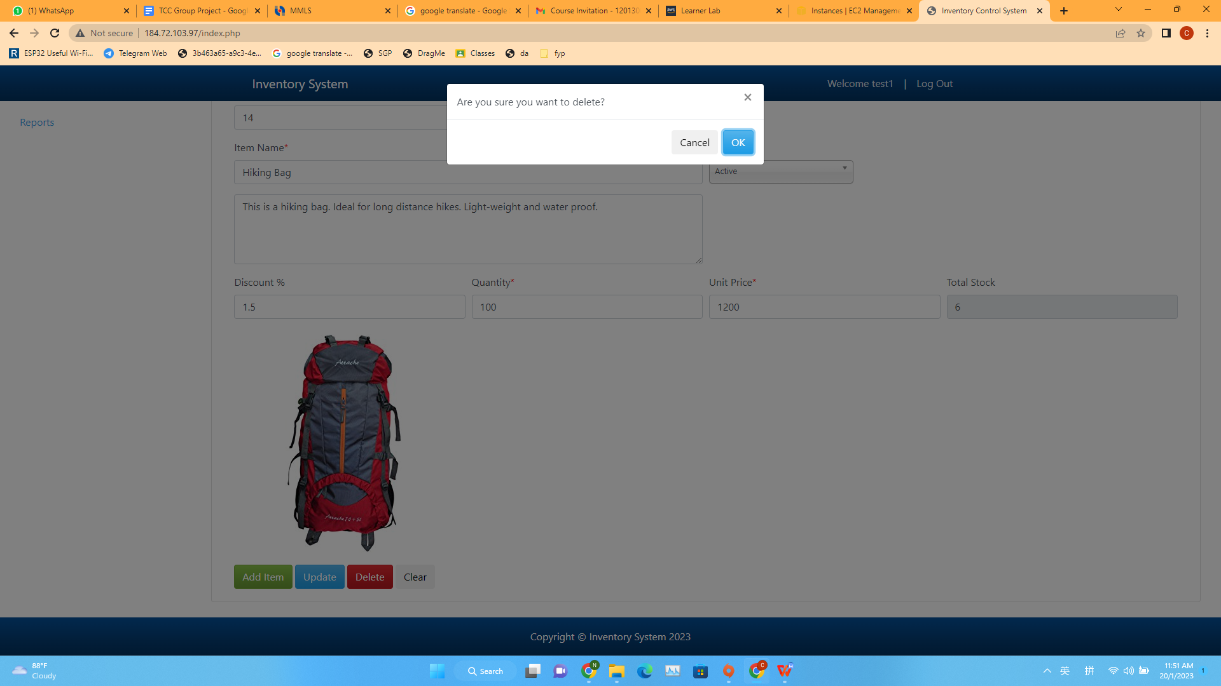

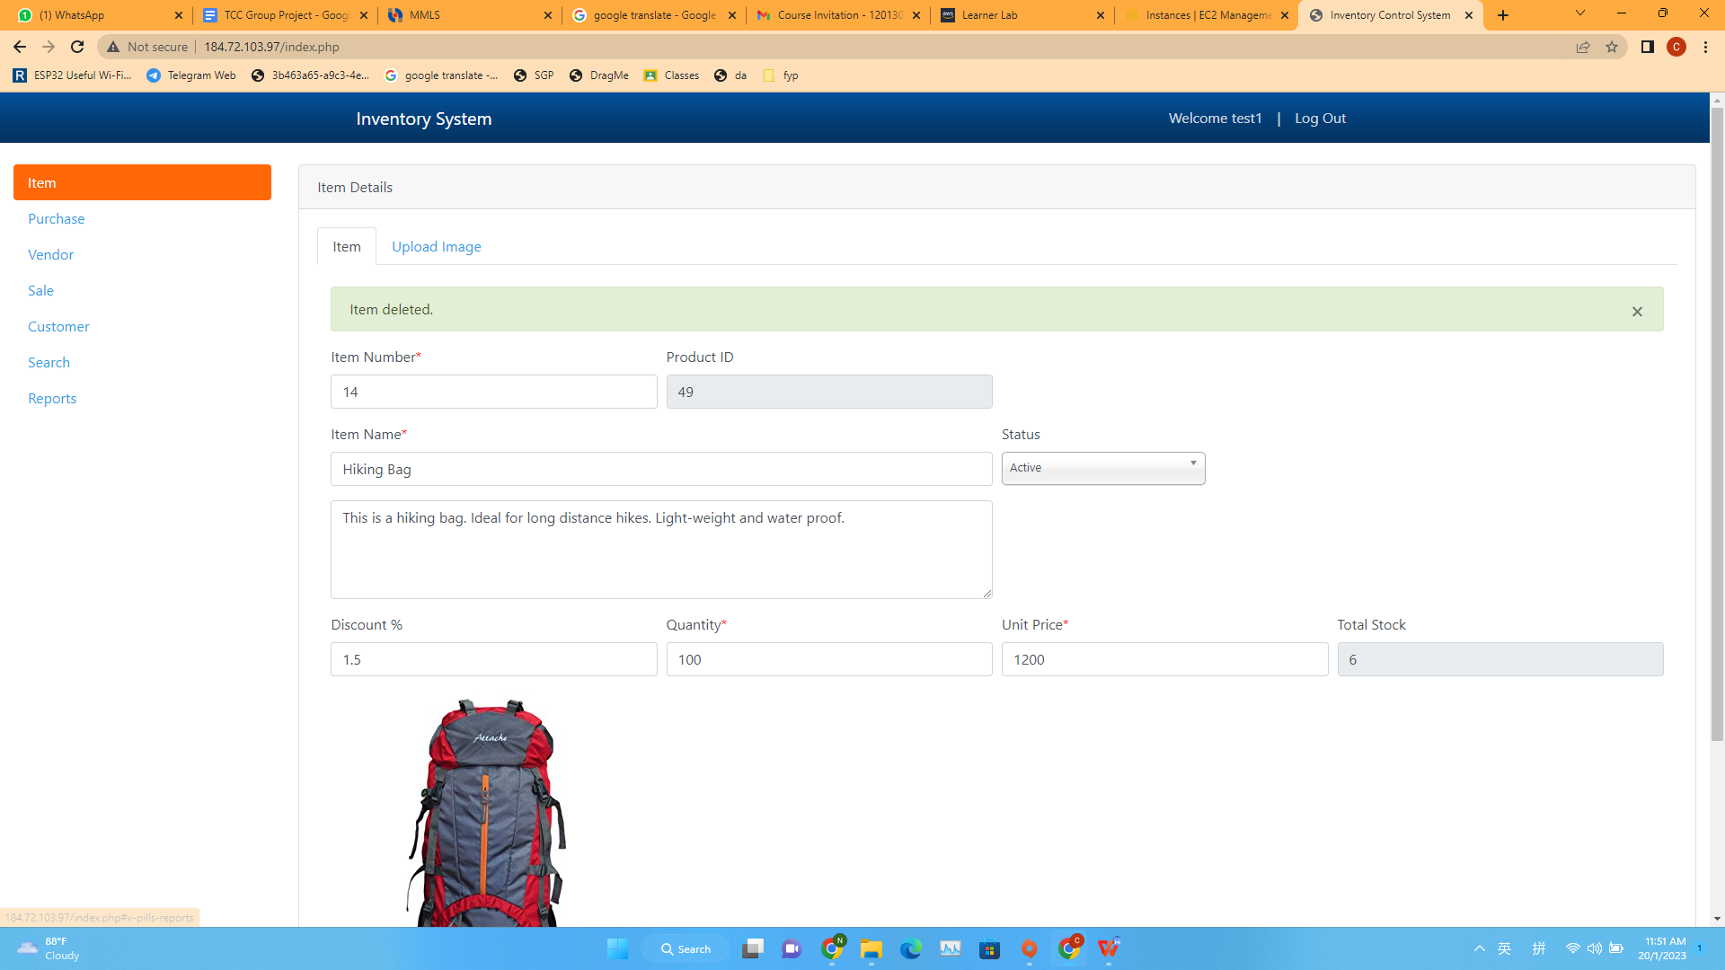

Database after delete item

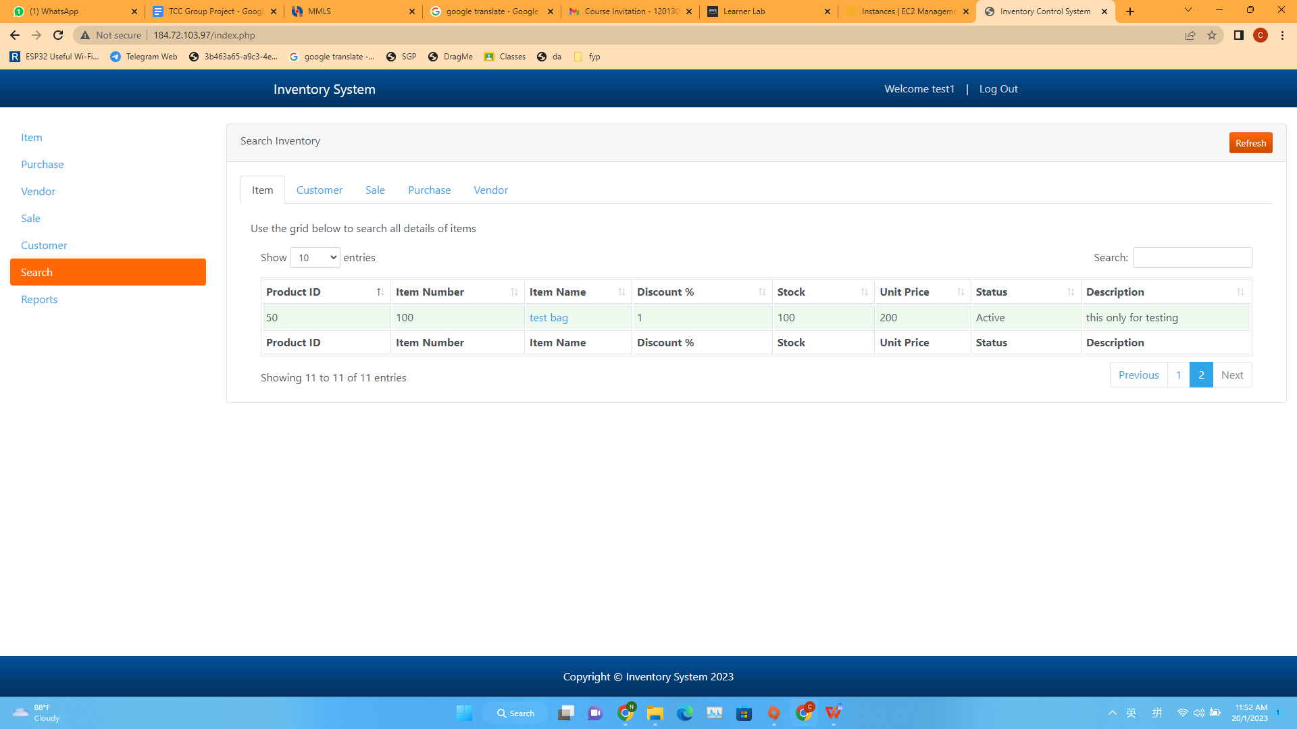

Item information update

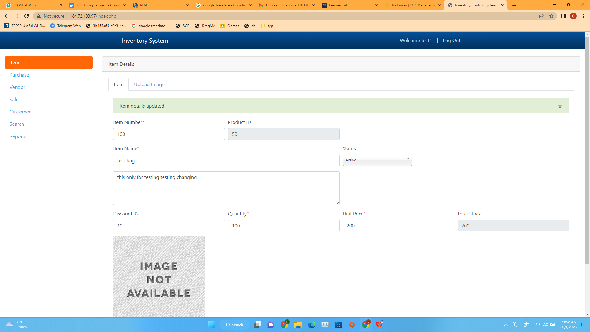

Database update

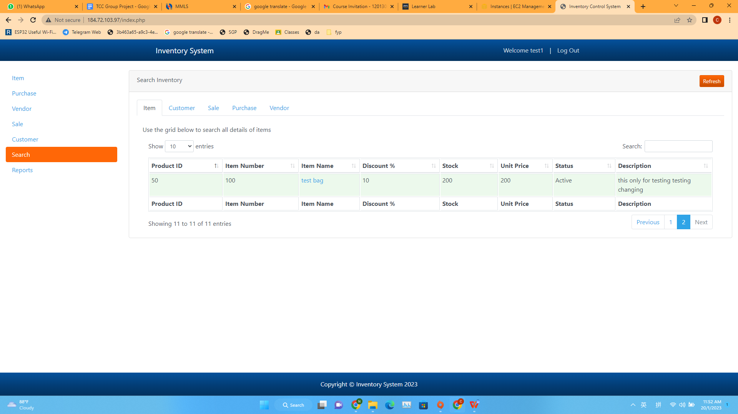

Purchase database testing

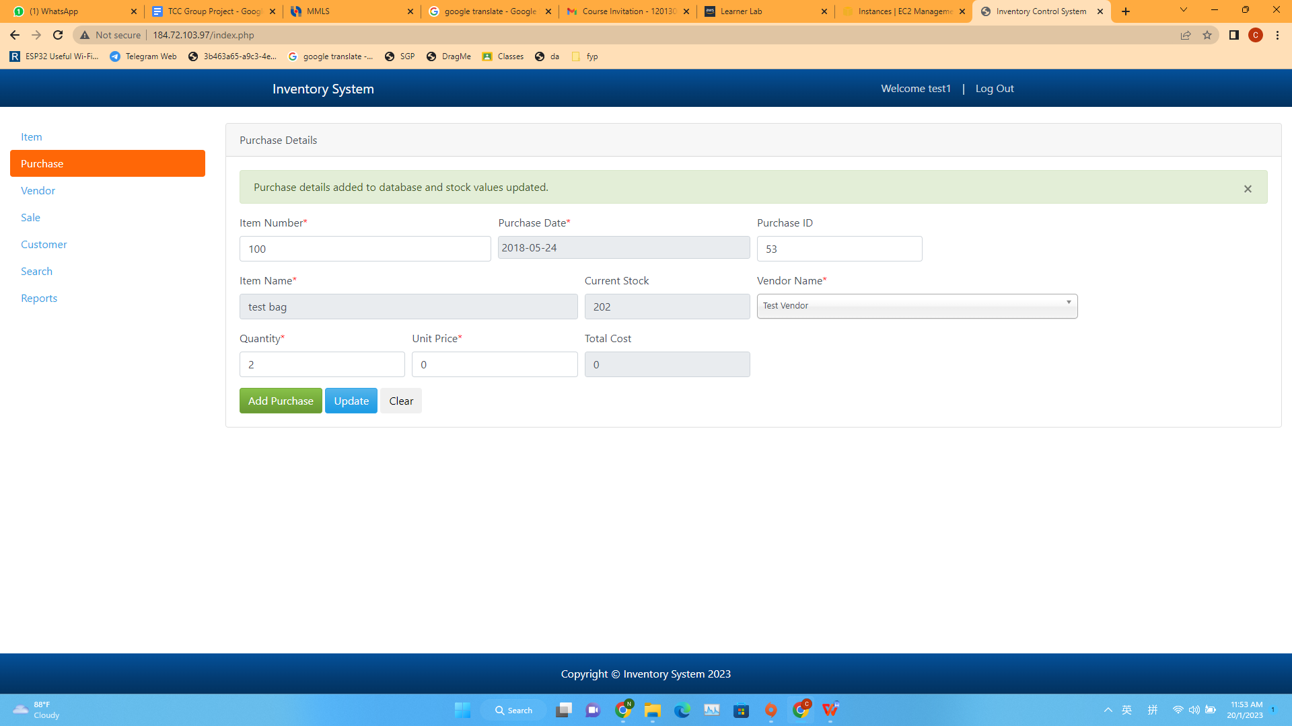

Database update

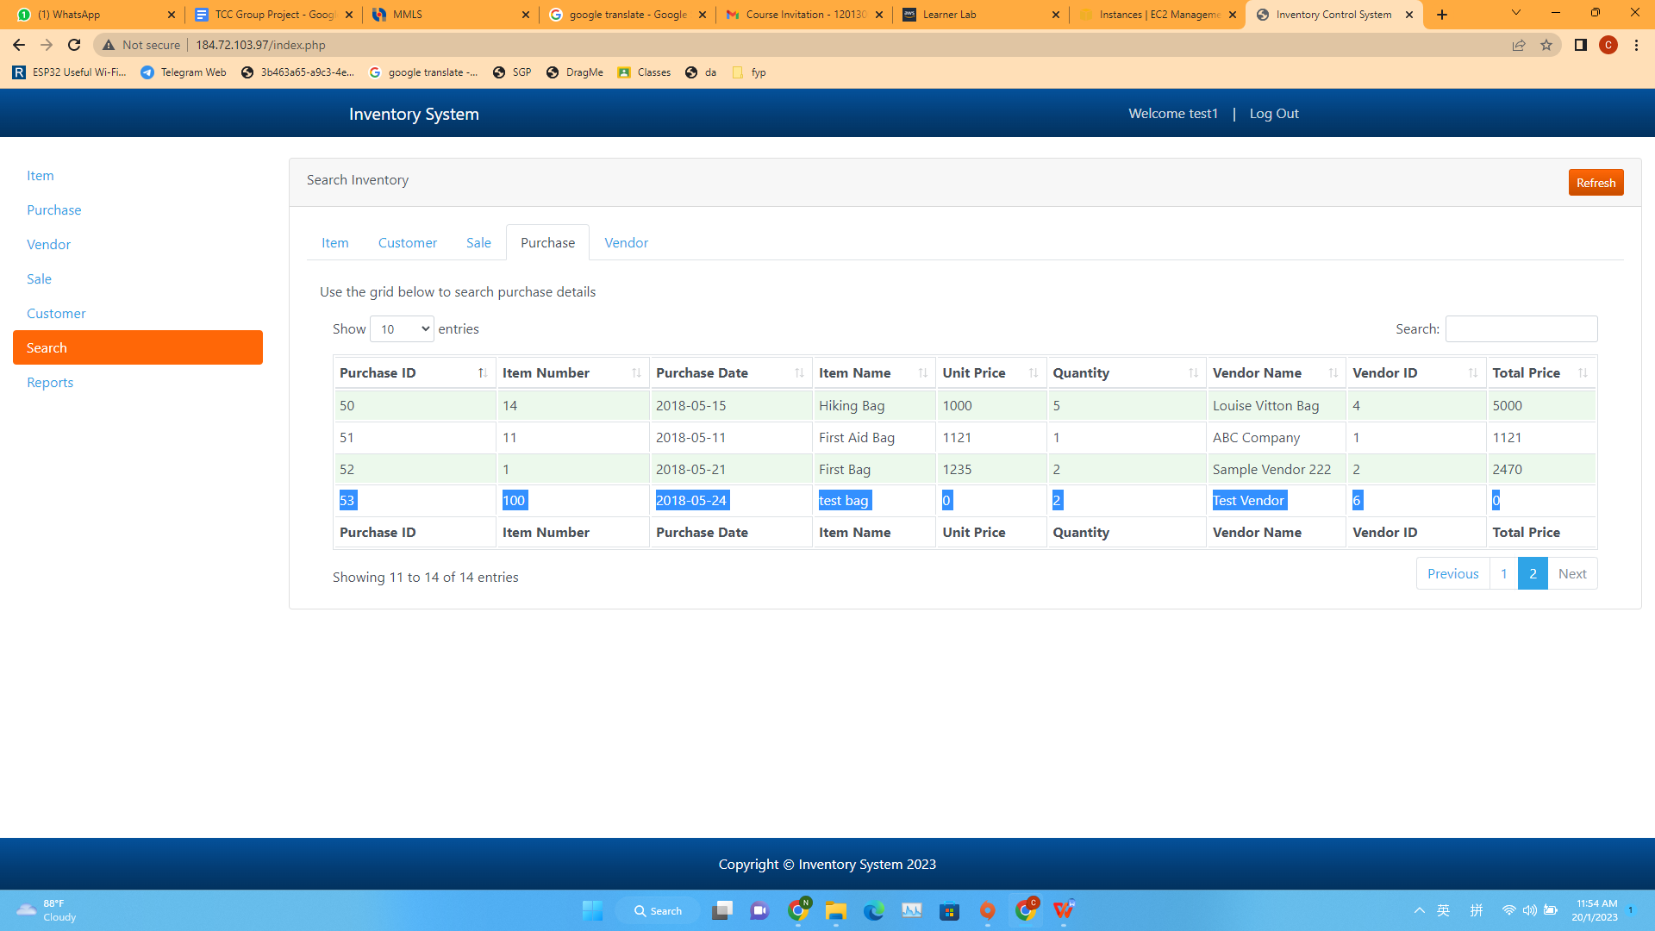

Other function of the website

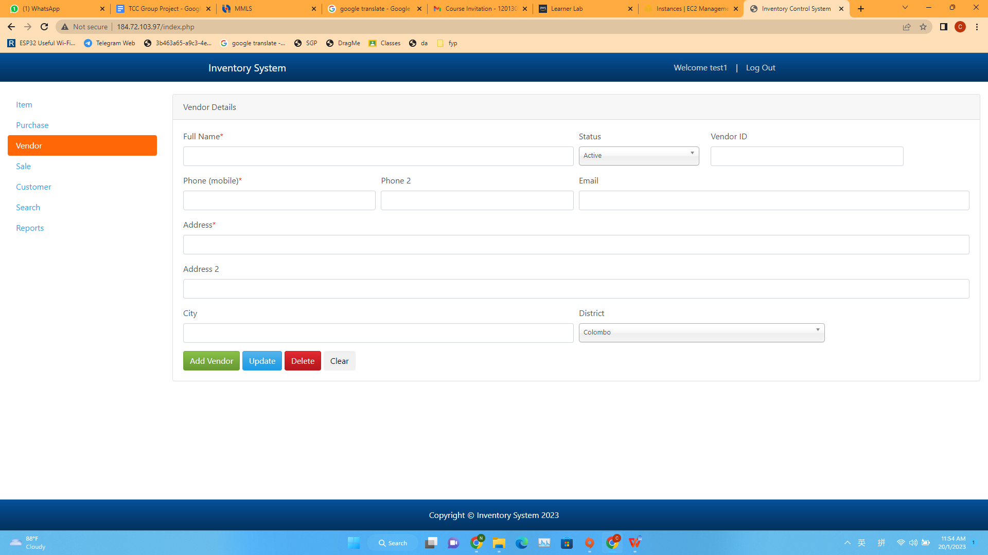

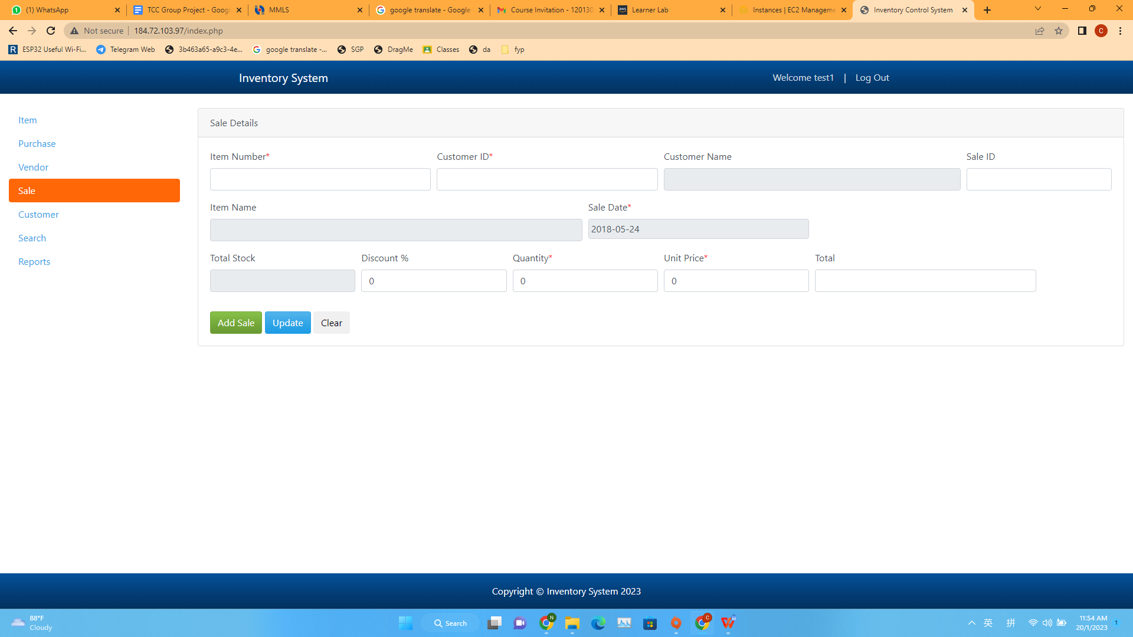

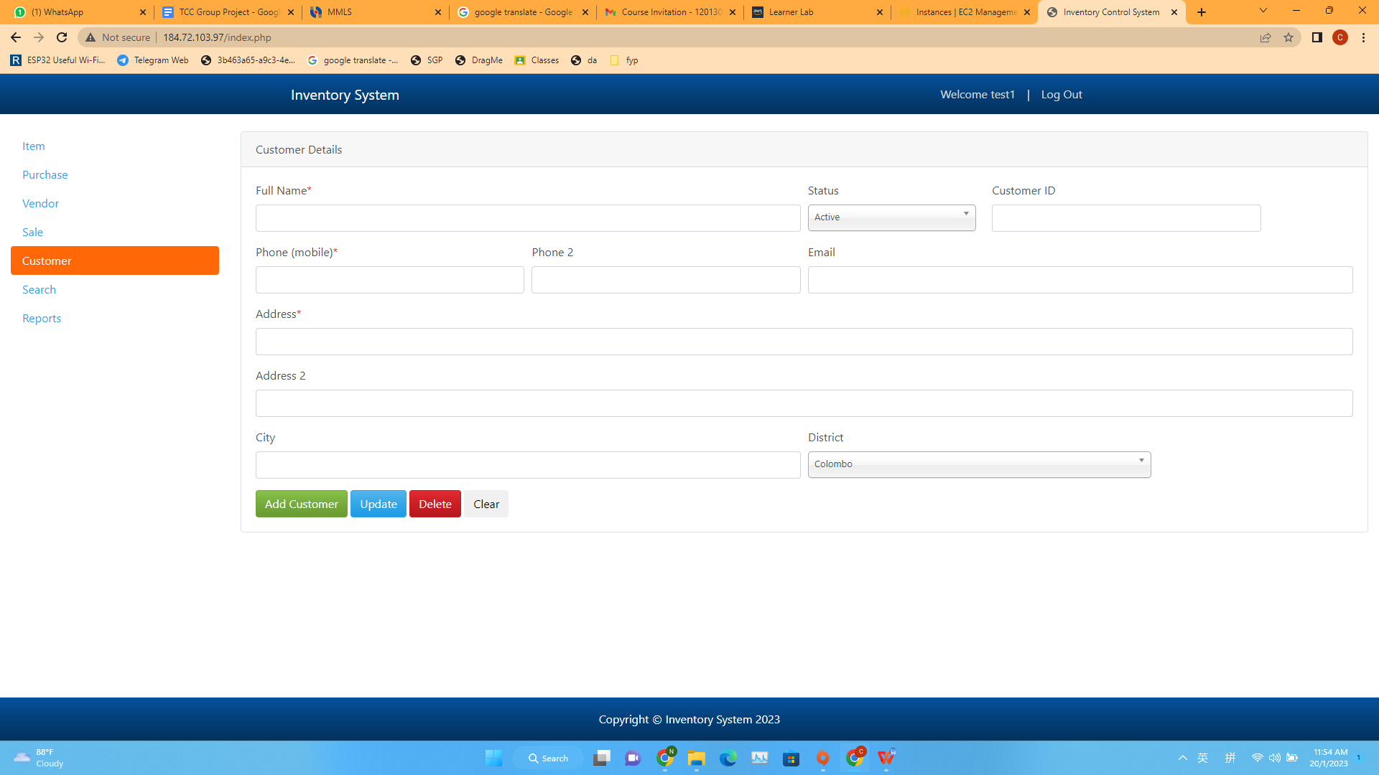

Network diagram:

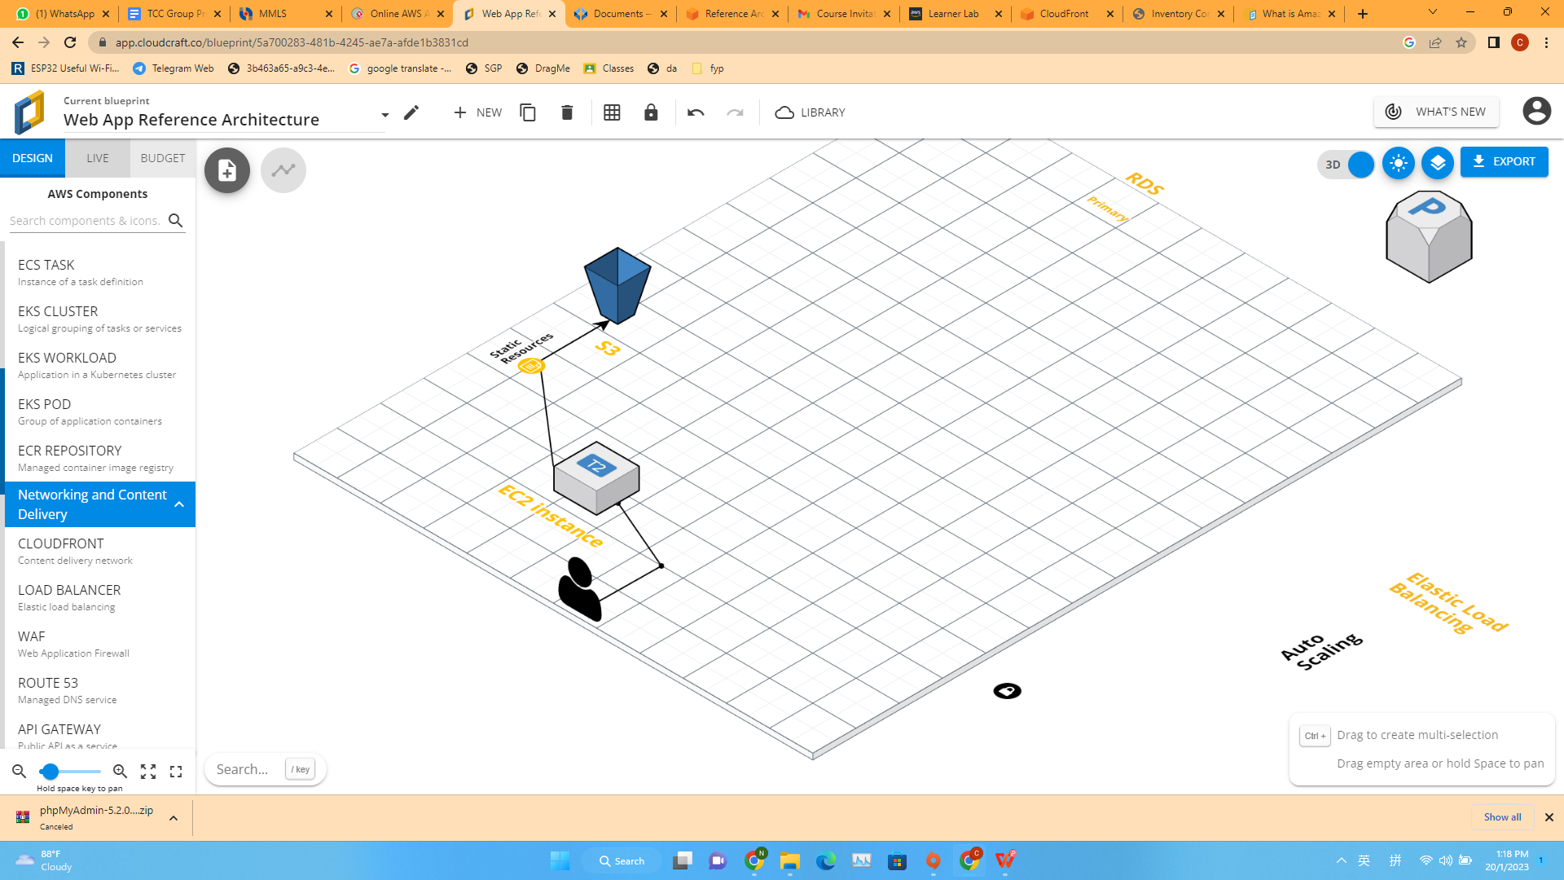

Phase 2 Break the Monolith

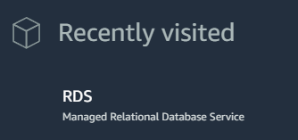

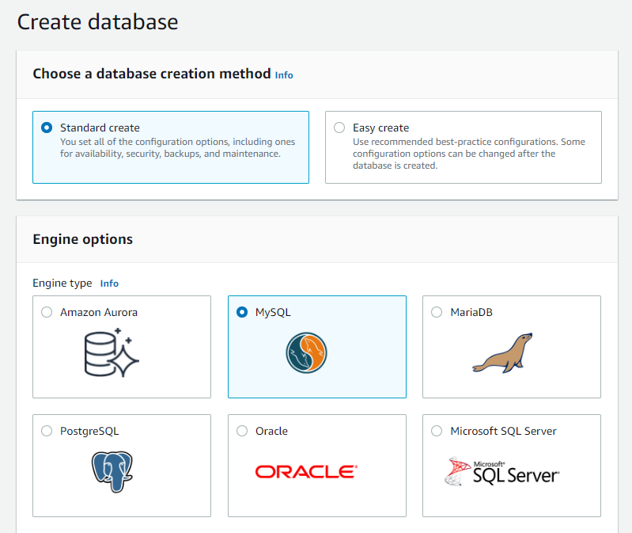

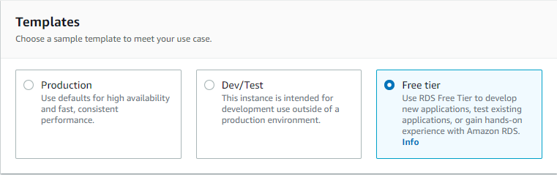

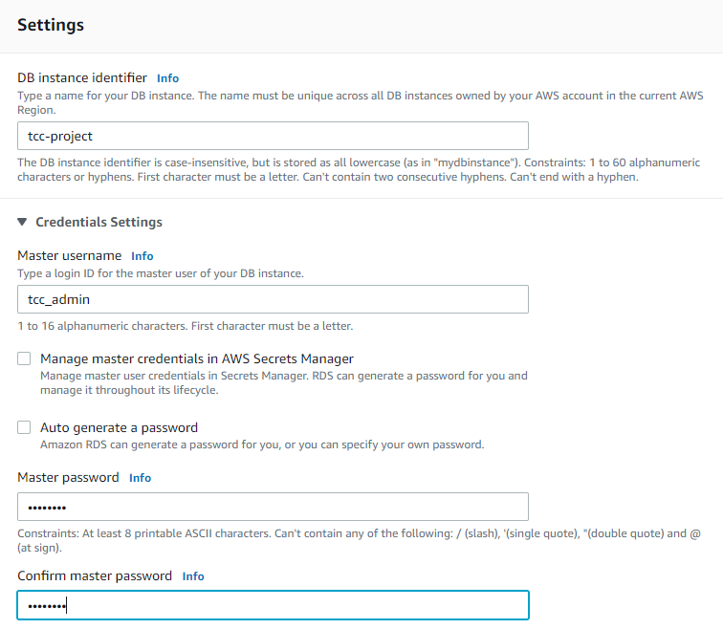

PASSWORD = “Aaa12345”

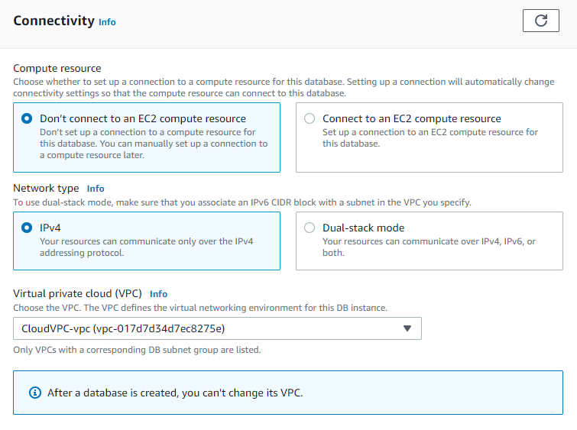

VPC change to default!!! Don’t use CloudVPC

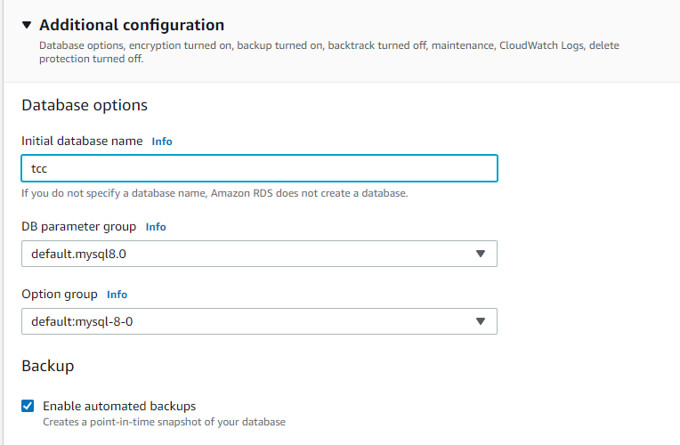

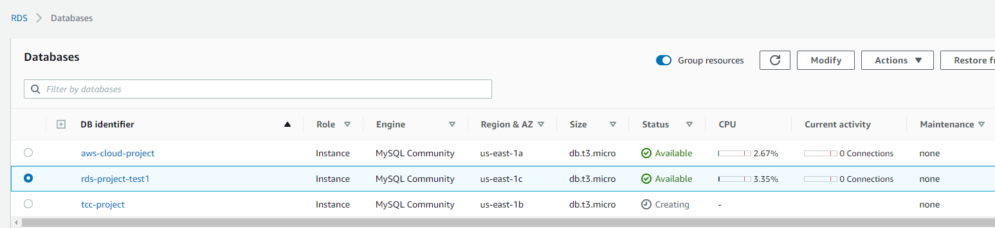

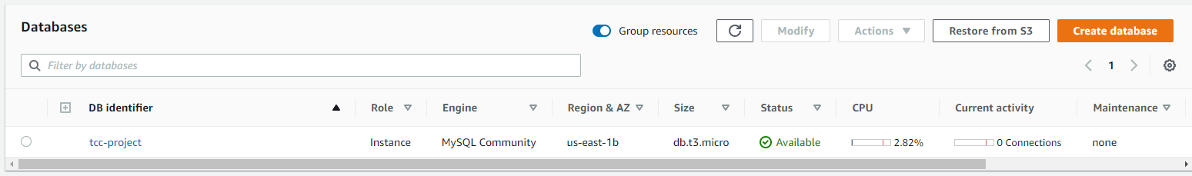

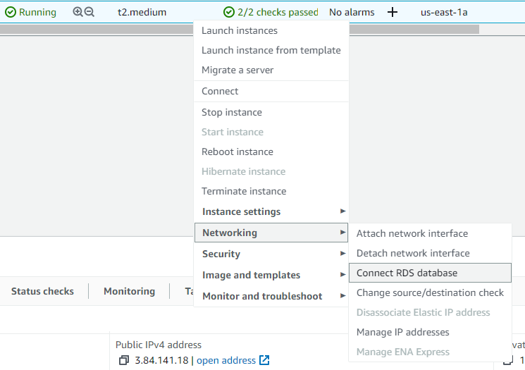

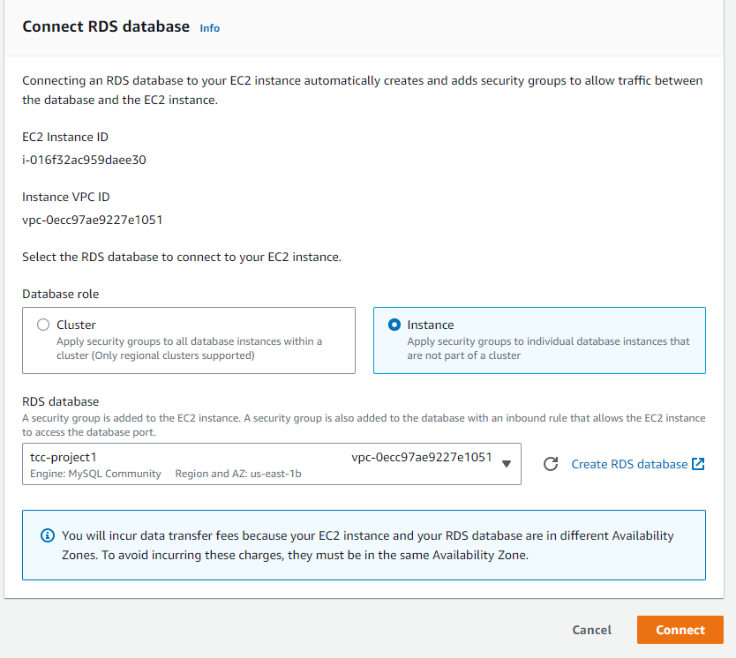

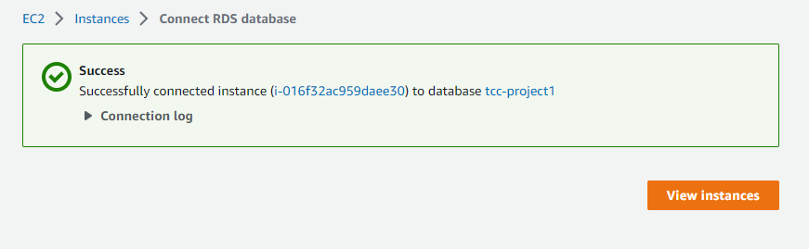

Go back to instance and view the security tab make sure have ec2-rds-1

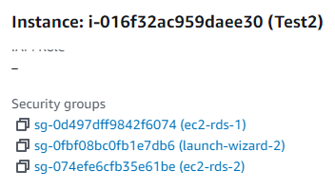

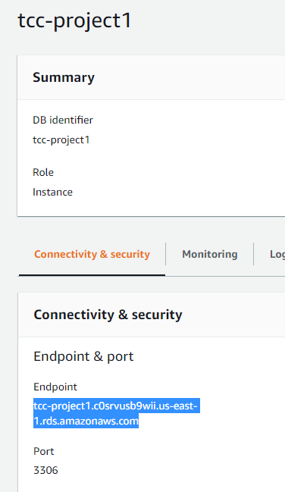

Go back to the database page and copy the endpoint.

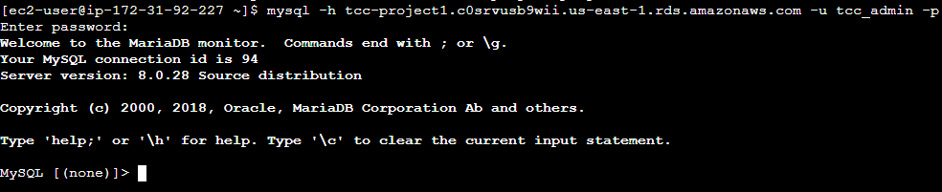

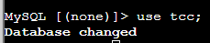

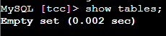

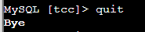

Import the SQL into the directory

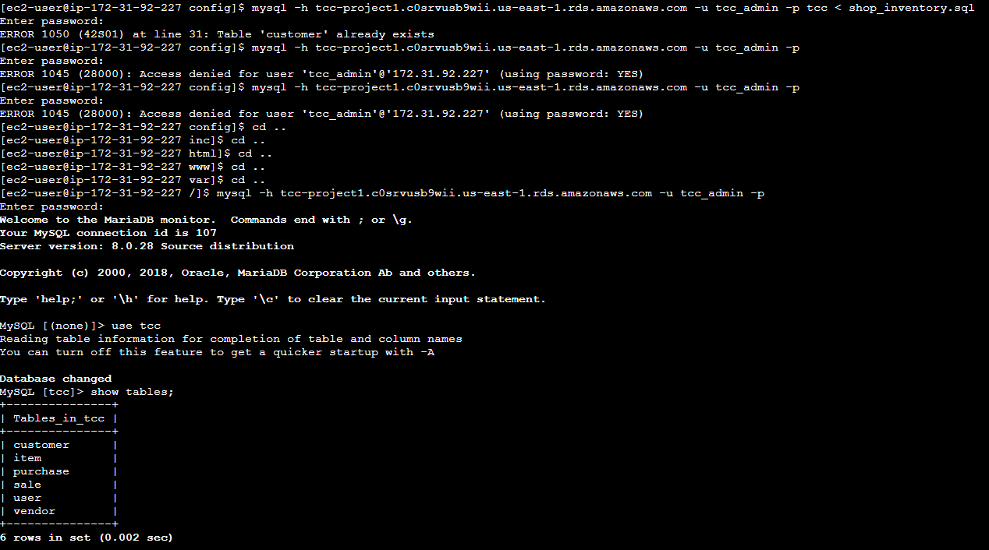

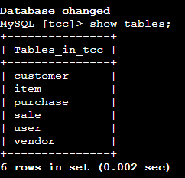



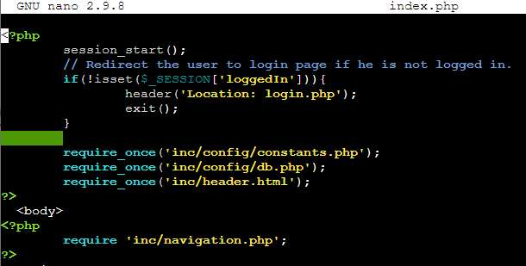

Network diagram:

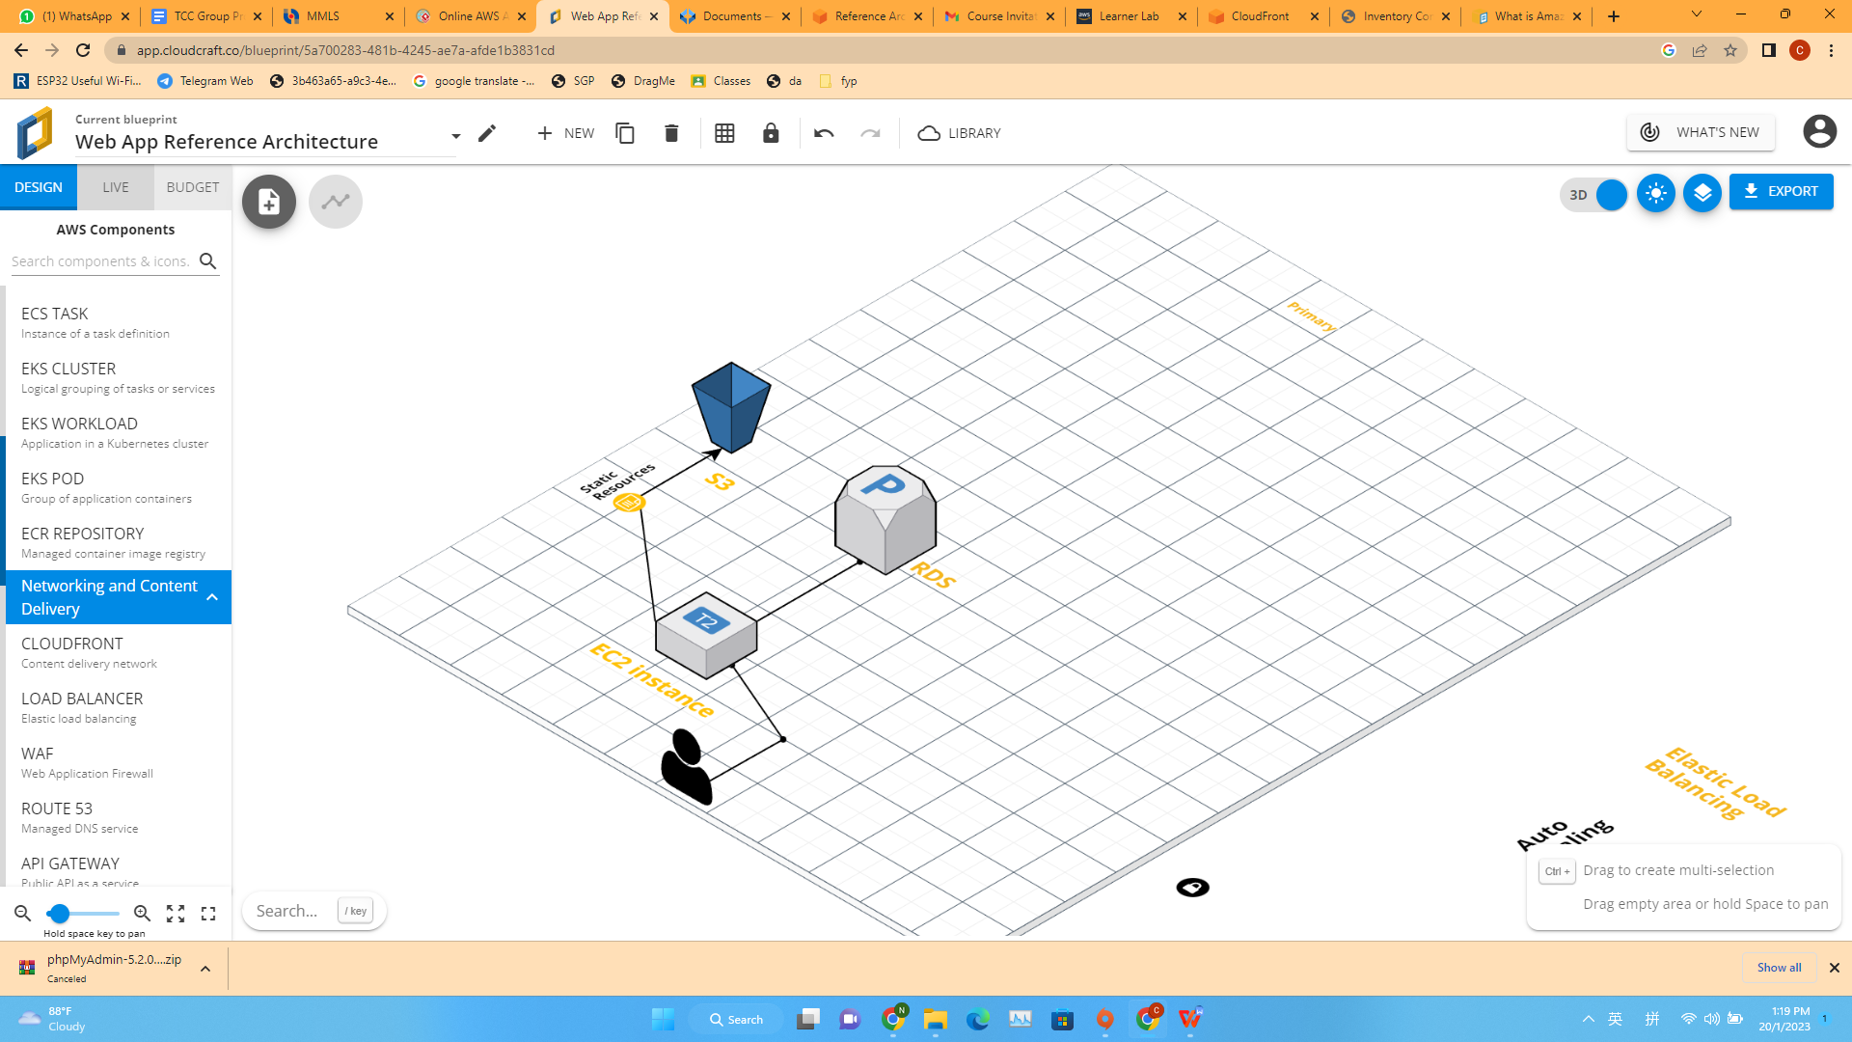

Phase 3 – Decoupling

**A new public subnet**

Create a new public subnet: Select services, then select VPC then select subnets then choose “Create subnet”. For the VPC ID, choose Cloud VPC-vpc. Next, subnet settings will be enter subnet name which is “Public Subnet”. For the IPv4 CIDR block will be enter “10.0.16.0/20”. After that, click “Crete Subnet”.

After this, go to route tables (on the left side), choose “Create Route Table”. Enter the name “Public Subnet” in route table settings and VPC will select “Cloud VPC-vpc”. Then choose “Create”.

At the bottom, choose “subnet associations”, and select “edit subnet associations”, then select the public subnet and save.

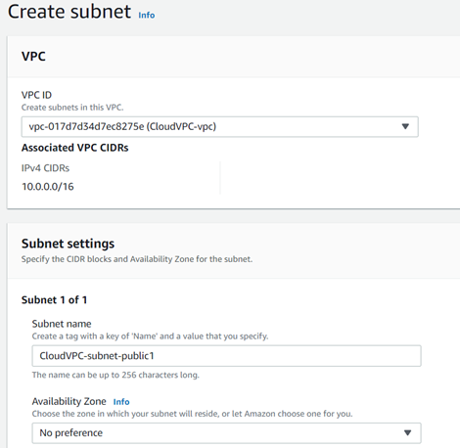

**Multi-AZ capability**

Select services, select database, select RDS. Select “Database” at the left side. Click on the database that we create before, at the bottom, choose “connectivity & security”. Copy the url of the end  point.

At the upper right corner, select the “create a standby instance”. Then scroll down little bit then we can see “Availability & durability”. Select the “Create a standby instance”. Then scroll down to bottom and select continue. At the schedule modifications, tick the “apply immediately”. Then select Modify DB instance. After modify done, click the database, scroll down and see the replication.

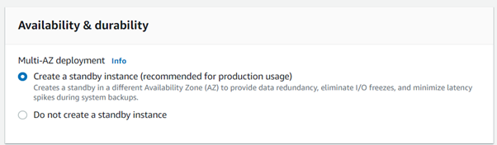

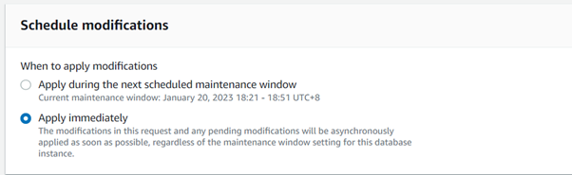

**Accessible ELB DNS**

Select services, select the EC2, select the “targets group” on the left side. Choose “Create target group”. Enter the target group name. For the VPC, choose the Cloud VPC-vpc. Then, click “Next”. Then choose “Create target group”.

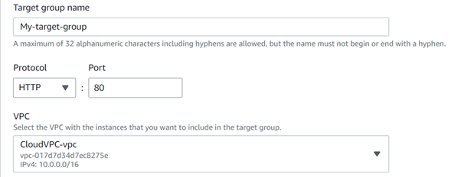

Click “Load Balancers” from the left side and select “Create Load Balancer”. On the “Application Load Balancer”, click “create”. Enter the Load balancer name, for the VPC, select “Cloud VPC-vpc”. Next, for the “Mappings”, tick us-east-1a (use1-az2) and us-east-1b (use1-az4). Next, fot the Listeners and routing, select the target group that we create beginning. After that, select “Create load balancing”. Then, select the view load balancers then we can see the Load balancers that we create.

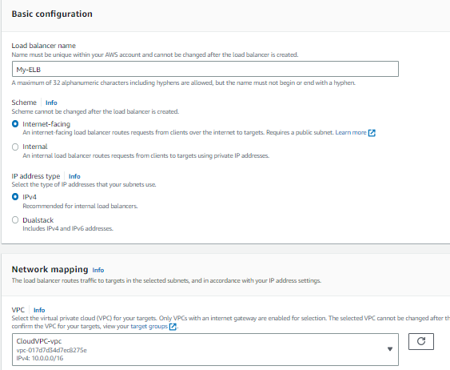

Network diagram:

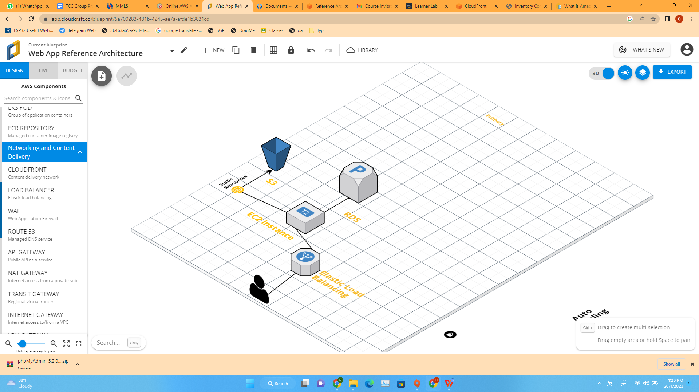

Phase 4 Scaling

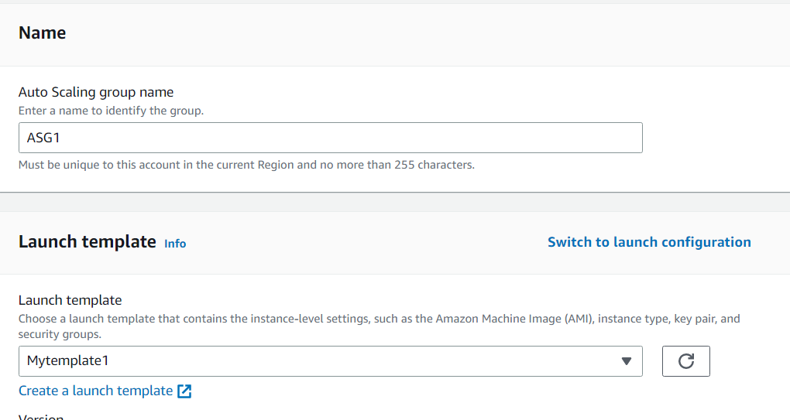

First type name and launch template

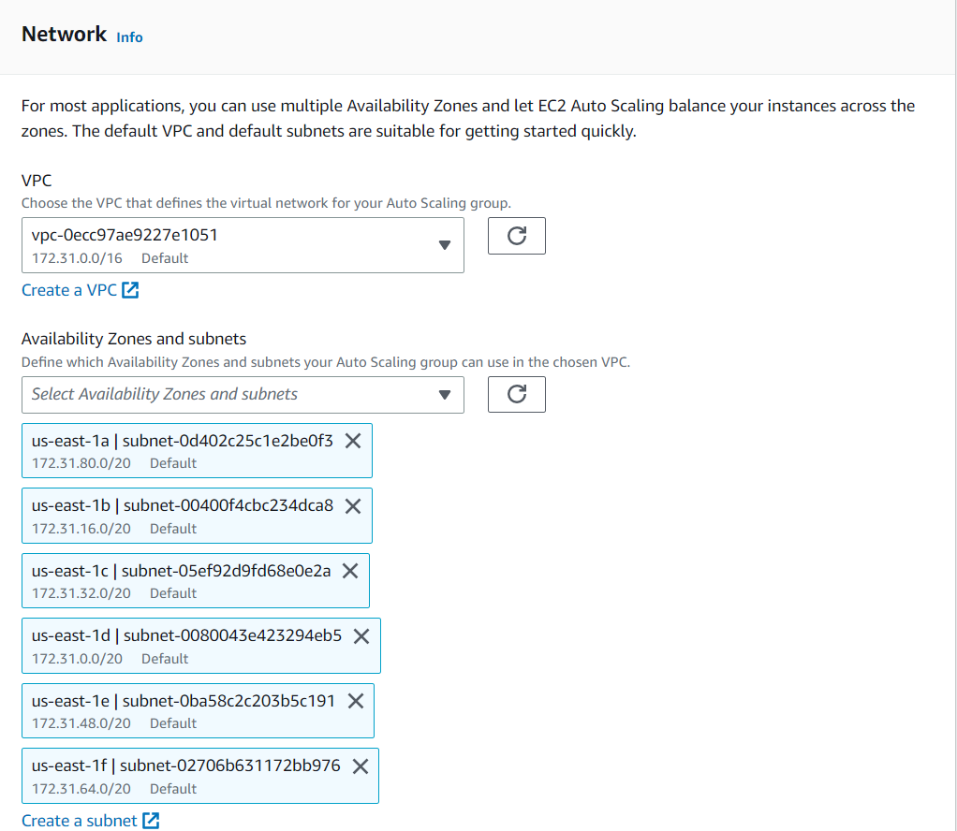

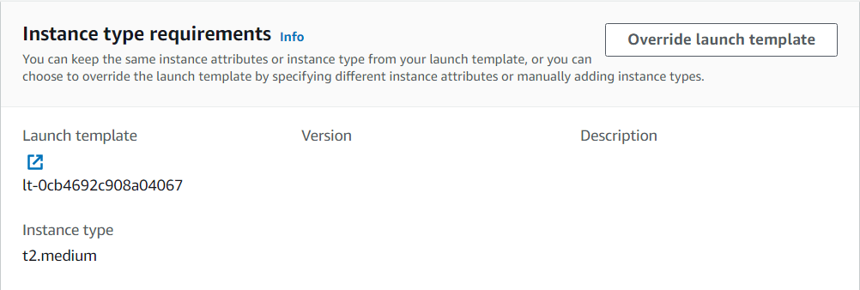

Choose vpc (auto choose) and subnet

Then skip to review

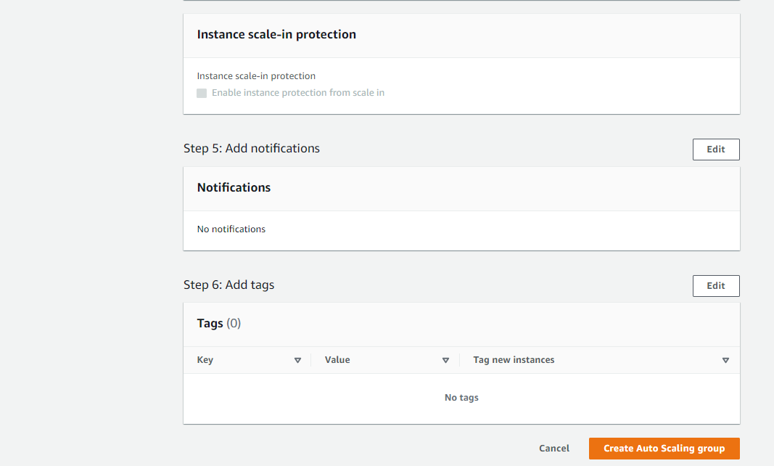

Create auto scaling group

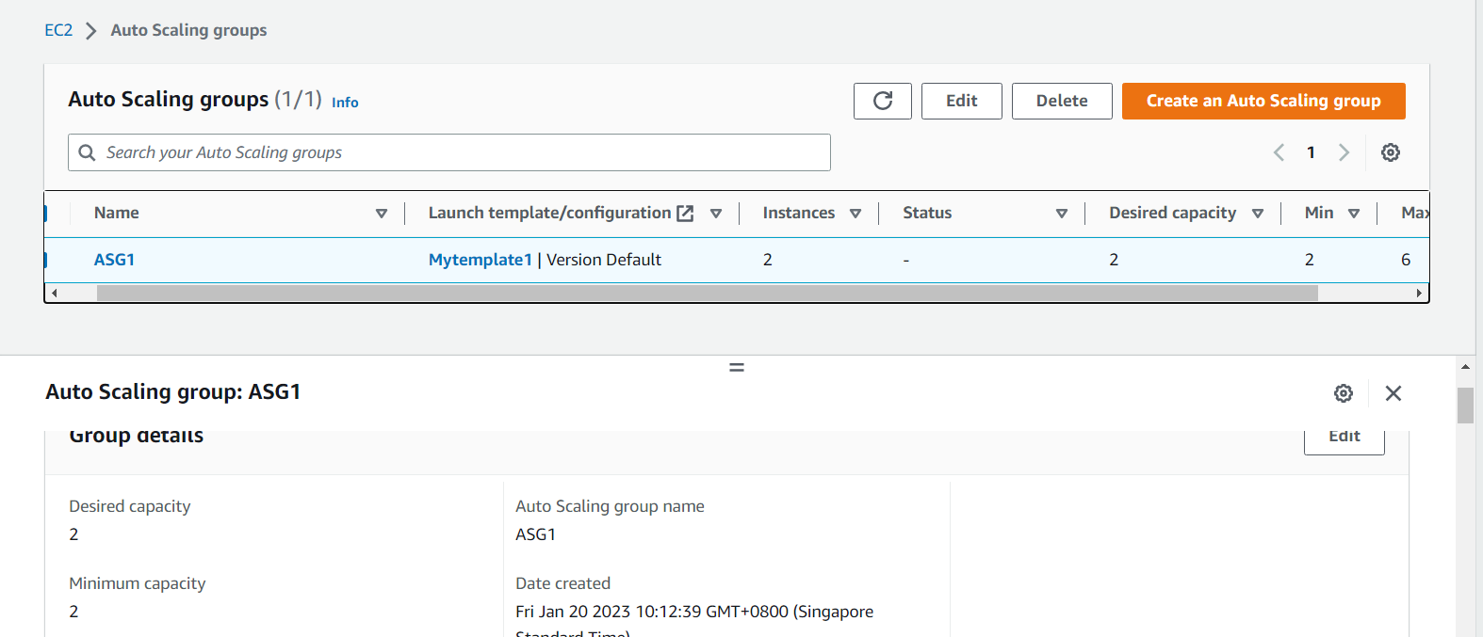

Number of instance

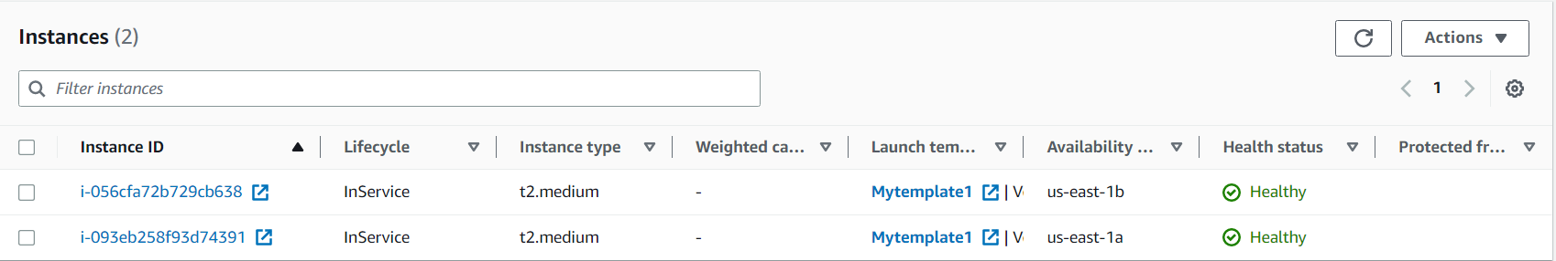

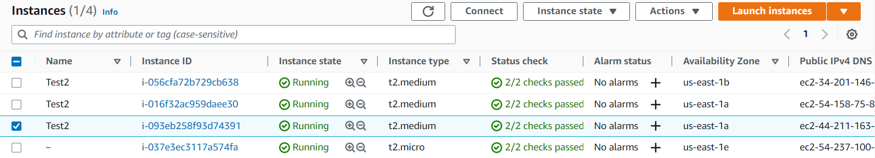

Create scaling policy

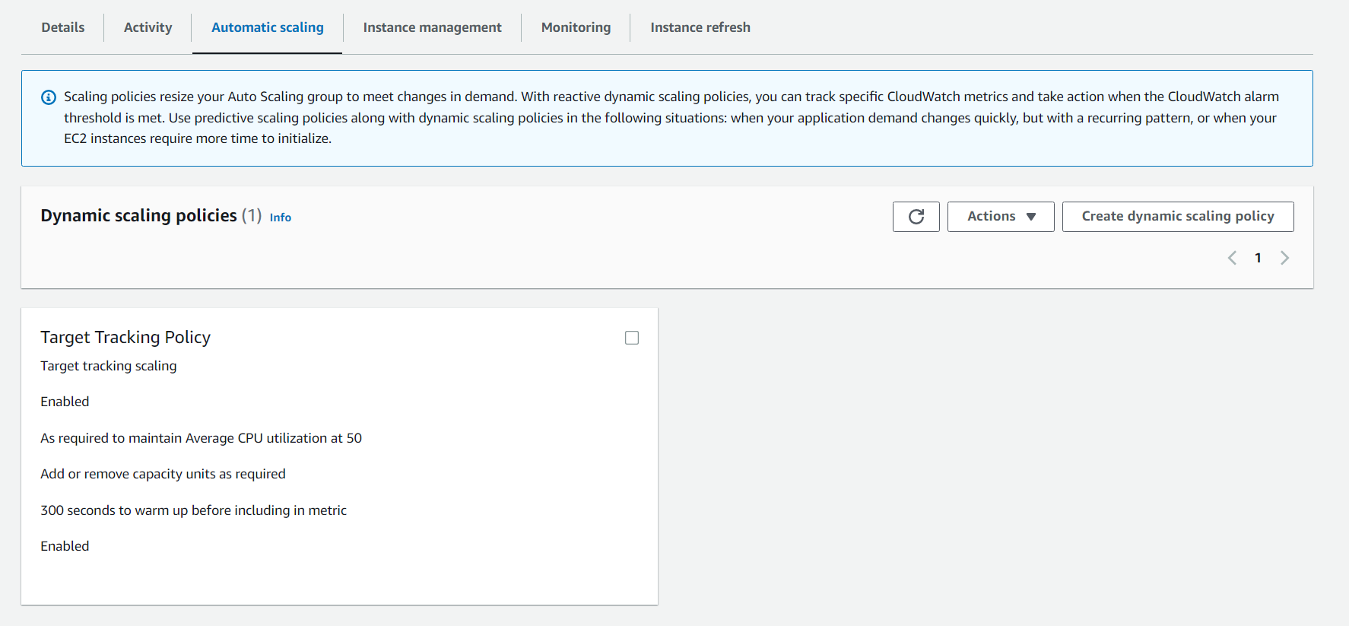

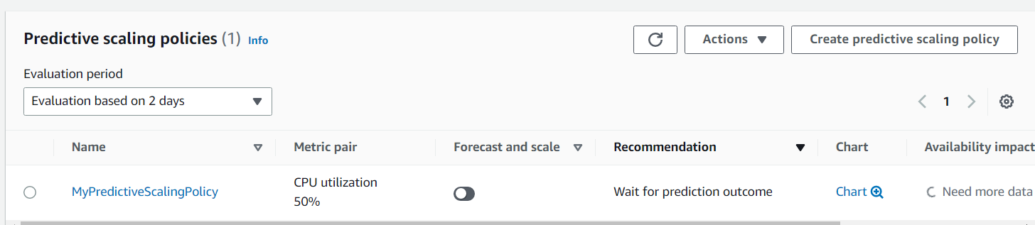

When create no need change anything

Network diagram:

